|  |
| --- |
| online banking system |
| dau_logo_BW  EASTERN MEDITERRANEAN UNIVERISTY  INFORMATION TECHNOLOGY  **ITEC315**  **SYSTEM ANALYSIS AND DESIGN**  **TERM PROJECT**  Presented By:  Osama bahamid : 139204  AboBaker Ahmed salem AlAttas: 137561  ACADEMIC YEAR: SPRING 2018 – 2019 |

# ContentS

|  |
| --- |
| 1.1Indtroduction1.1.2 Progect Description  * 1.1.3Scope * 1.1.4Objective * 1.1.5 Benefits * 1.1.6Outcomes * 2.1 system requirement documentation * 3.1.1Activity diagram * 3.1.2Event list * 3.1.3Event table * 3.1.4Use case diagram * 3.1.5Use case template * 3.1.6Domain class diagram * 3.1.7Navigation diagram * 4.1.1Design class diagram * 4.1.2 Sequence diagram * 4.1.3Navigation diagram * 4.1.4Package diagram |
|  |

# 1.1.2Description OF tHE project

|  |
| --- |
| * Banking Online, which known as Internets banking, it' an online payment systems which enable clients of the bank to carry out variety of financial transaction into their website. That is a part of the central banking system. * main aims of our project is to provide a reliable and safe system. |
|  |

# 1.1.3Scope OF the system

Online Banking system are considered to be one of the most thing making our life a lot easier. Online banking services help us to save a lot of time, trading and business can't be carried on smoothly. Online banking it will change a lot of things in the near future.

# 1.1.4objective of the system

|  |
| --- |
| * Identify the problem in online banking on the banks website. * Allow only authorized users to access various functions and processes available on the system. * Provide more speed and less time consumption. * Best client service. * create an easy-to-use system |
|  |

# 1.1.5BENEFITS of the system

|  |
| --- |
| 1) Register the issuer of public service invoices and make the payment  2) Offers banking services all year round, 24/7 days from anywhere, with Internet access.  3) Make your transactions in foreign currency.  4) Simplify the reconciliations of your account and make investments.  5) Take advantage of all the services you need regardless of how big or small your company is.  6) Provides security and privacy to clients through the use of latest generation encryption and security technologies.  7) Reduced administrative work like most computer work.  8) Analyze the importance, functions, advantages and limits of online banking.  9) Save time spent at the bank. |

# 1.1.6OUTCOME of the system

|  |
| --- |
| Seeing a new concepts of changing technology and gain a lot of experience in many area's that include computers usages. Client's life will be much easier by using online banking they could access their account at anytime and anywhere. Which will easily reduce human effort and speed.  **2.1SYSTEM REQUIREMENT DOCUMENTATIONS UML\_DIAGRAM**  1 Login to the system 1.1.system shall all users to enter the web site 1.2.system shall show the login page  1.3.system shall permit users to enter credentials 1.4.system shall verify the users 1.5.system shall inform the users if they're wrong and permit the users to enter the proper details  1.6.system shall show the homepage  2. Logout of the system  2.1.system shall permit users to logout  2.2.system shall show log-in page when users has logged-out  3. confirm an exist client  3.1.system shall permit users to enter client detail's  3.2.system shall search name's with in database  3.3.system shall permit the users to open a new file and assign client\_id  3.4.system shall permit the user to click on confirm client  3.5.system shall verify and show "success" notification  4. confirm new client  4.1.system shall permit users to enter client details  4.2.system shall search name's within the information  4.3.system shall show client detail's as well as client\_id  4.4.system shall permit the users to clicks on confirm client  4.5.system shall verify and show "success" notification  5. close account  5.1.system shall permit the client to receive notifications  5.2.system shall permit the users to entering client \_id  5.3.system shall show client details if the entered client\_id is correct  5.4.system shall permit the user to clicks on close account  5.5.system shall updates database  6. Updated client details  6.1.system shall permit users to enter client\_id  6.2.system shall verify client\_id  6.3.system shall notifies users to enter correct id if the entered client\_id is wrong  6.4.system shall show the client details if the entered clent\_id is correct  6.5.system permits the user to update's details  6.6.system shall permit users to enter new detail's  6.7.system shall modify the detail's in database  6.8.system shall show updated notifications  7. display client activity  7.1.system shall permit users to enter client\_id  7.2.system shall verify client\_id  7.3.system shall inform the users to enter the right client\_id if the entered client\_id is wrong  7.4.system shall show the client details if the entered id is corrects  7.5.system shall permit users to view client activity  7.6.system shall show client activity  8.checking account  8.1.system shall enable the clients to clicks on checking account  8.2.system shall show account detail's  9. exchange currency  9.1.system shall enable the users to choose a currency  9.2.system shall show currency rate  9.3.system shall enable user to enter the amount of money  9.4.system shall verify the amount of money  9.5.system shall notify the user to enter correct amount of money if the amount has entered is wrong.  9.6.system shall approved exchange currency if amount of money is right  10.Money transfer  10.1.system shall enable users to put account number  10.2.system shall enable users to put the amount of money to transfer  10.3.system shall verify the account number  10.4.system shall verify the amount of money  10.5.system shall notifies users if the entered account number is wrong to enter the correct account number  10.6.system shall notifies if the entered amount of money wrong to enter correct amount of money  10.7.system shall approved money transfer if account number and the amount of money are correct  11.Bill payments  11.1.system shall enable users to type bill number  11.2.system shall verify bill number  11.3.system shall notifies users if bill number is wrong  11.4.system shall show bill detail's if typed number is correct  11.5.system shall enable users to verify amount  11.6.system shall enable users to make payment  12. investments  12.1.system shall enable users to choose an investment  12.2.system shall show investments rate  12.3.system shall enable user to put the amount of money to invest  12.4.system shall verify amount of money  12.5.system shall notify users to type the correct amount of money if the typed amount of money is wrong  12.6.system shall approved the investment if amount of money is corrects |

**PHASE2**

**3.1.1Activity Diagram**

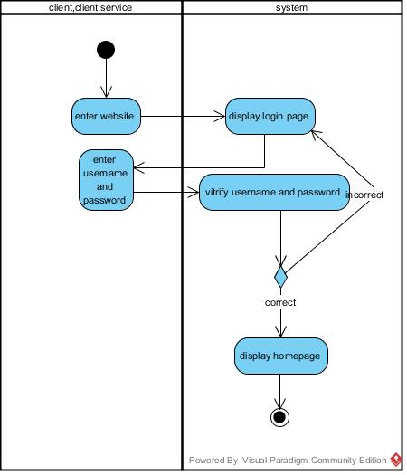

# login

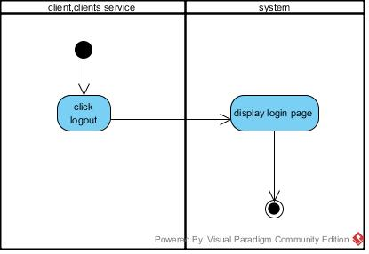

**LOGOUT**

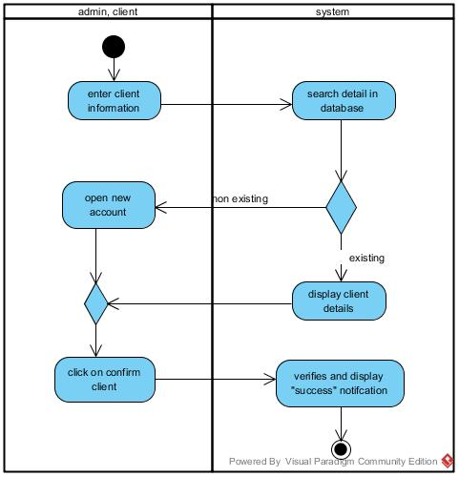

**Confirm client and confirm new client for activity diagram**

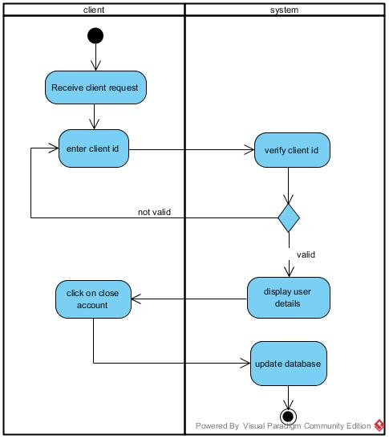

### close account for activity diagram

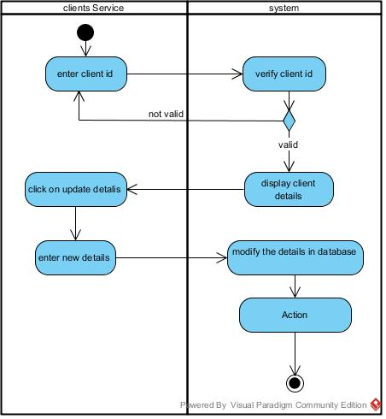

### update client details for activity diagram

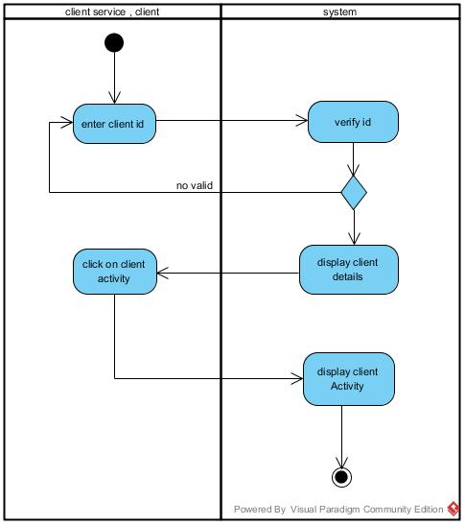

### display client activity for activity diagram

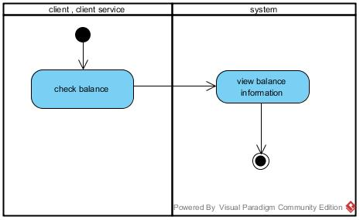

### checking account for activity diagram

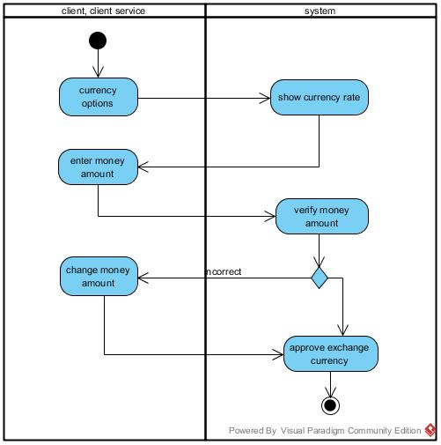

### exchange currency for activity diagram

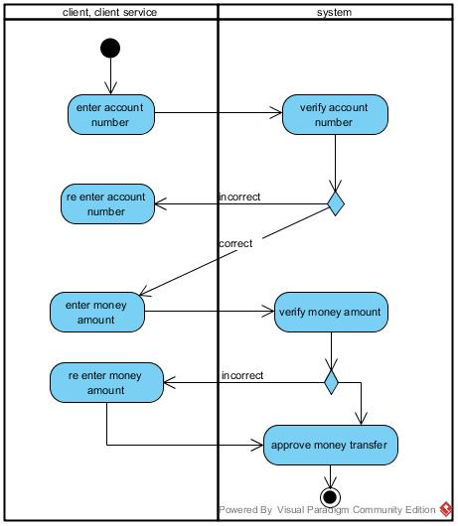

### money transfer for activity diagram

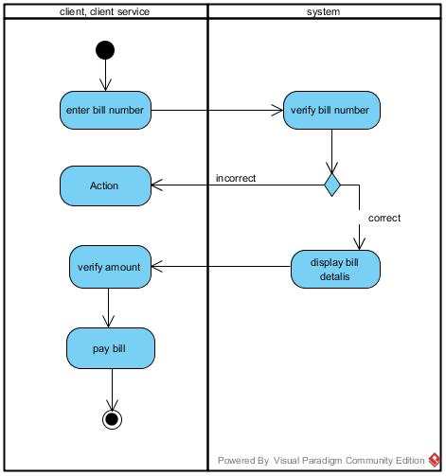

### bill payment for activity diagram

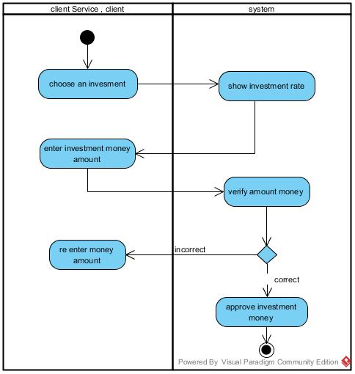

### investment for activity diagram

### 3.1.2EVENT LIST'S

1. Login to the system
2. Logout of the system
3. Confirm an exist client
4. Confirm new client
5. close account
6. Update client details
7. Display client activities
8. Checking account
9. exchange currency
10. money transfer
11. Bill payments online
12. Investment

### 3.1.3Event Table

|  |  |  |  |  |  |
| --- | --- | --- | --- | --- | --- |
| Event | Triggers | Sources | Use Cases | Responses | Destination |
| 1. Login | Client click "Login" | client, client service | Logging into the system | Display homepage | client, client service |
| 1. Logout | Client clicks "Logout" | client, client service | Logging out of the system | Display login page | client, client service |
| 1. Confirm existing client | Sign up | manager | Confirm client | Client detalis | Client service |
| 1. Confirm new client | Sign up | Client service | Confirm new client | client details (name, account no. etc) | Client service |
| 1. Close account | Client click "close account" | client | Closing account | Show client closing | client |
| 1. Update client details | Search “client details” | Client service, clients | Updating client details | Updated client details | Client service |
| 1. Display client activities | 1. Client clicks“ client activities   ” | Client | Viewing client activities | activities details | Client |
| 1. Checking account | Client clicks “check account” | Client | Checking accounts | Checking amount | Client |
| 1. exchange currency | Client clicks “exchange currency ” | Client | Exchanging currency | Exchange rate | Client |
| 1. Money transfer | Client clicks “money transfer” | Client | Transferring money | Enter account number and amount | Client |
| 1. Bill payments | Client clicks "bill payments | Client | Bill payments | Bill details and amount | Client |
| 1. Investment | Client clicks "investment | Client | investments | Investments details | Client |

### 3.1.4Use case diagram

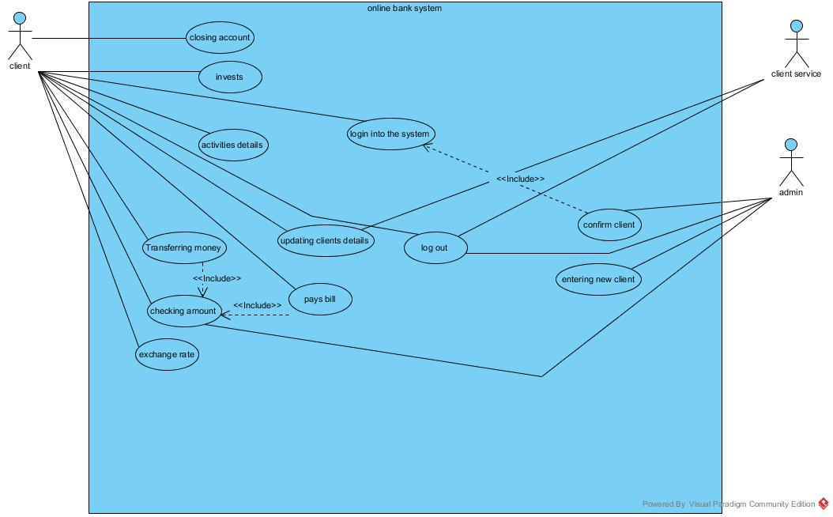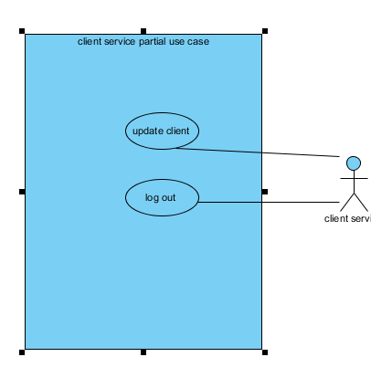

**Partial use case for new client**

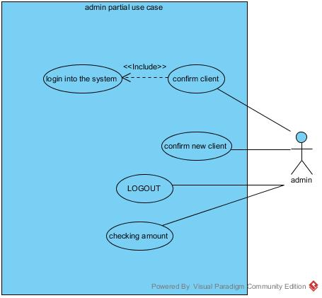

**Partial use case for admin**

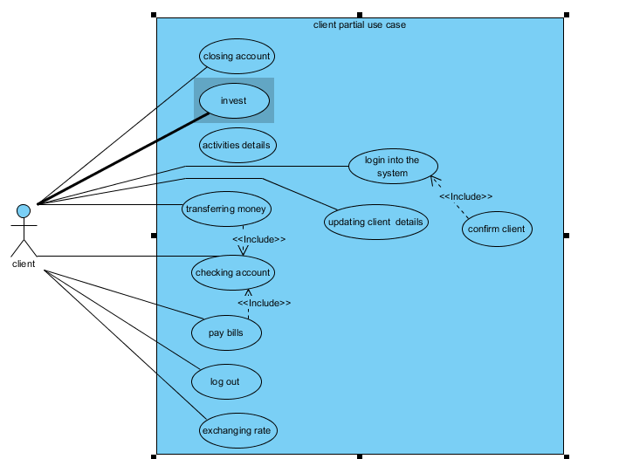

**Partial use case for client**

|  |  |  |
| --- | --- | --- |
| Use Case Name | Log-in | |
| Scenarios | Users logs into the system | |
| Trigger Events | Users clicks "login" | |
| Descriptions | Users must have username and password to log into the system | |
| Actor | Clients | |
| Related use cases | <<Include>> confirm client | |
| Precondition | User must be authenticated and know the website | |
| Post condition | Users are given access to the system | |
| Flowing event | **Actor** | **System** |
|  | 1. user connects to website  2. Enter username and password | 1.1Display log-in page.  2.1verify user  2.2Display home page. |
| Exception Condition | 2.1If username and password are wrong,user won't be able to log-in. | |

# 3.1.5use case templatate

|  |  |  |
| --- | --- | --- |
| Use Case Name | Logout | |
| Scenarios | User log-out of the system | |
| Trigger Events | Users clicks on “Logout” | |
| Descriptions | Users logs out of system by clicking logout | |
| Actor | Clients , client service, admin | |
| Related use cases | none | |
| Precondition | User must be logged in first | |
| Post-conditions | User logged out of the system | |
| Flowing of event | **Actor** | **System** |
|  | 1. Clicks on “Logout”. | 1.1 Logs user out of system.  1.2 Displays home page. |
| Exception Condition | 1.1 User must be logged in to log out | |

|  |  |  |
| --- | --- | --- |
| Use Case Name | Confirm client | |
| Scenarios | Client enter user name and password | |
| Trigger Events | Checking the authentication of clients | |
| A Brief Description | The system checks client username and password and look it up through the database | |
| Actors: | Admin | |
| Related use case: | <<include>>login into the system | |
| Preconditions: | Client must exist | |
| Post-conditions: | client authentication verified . | |
| Flowing events: | **Actor** | **System** |
|  | 1.Checking client user name and password that's entered | 1.1 verify client authentication |
| ExceptionConditions | 1.1If account isn’t valid,display an error message | |

|  |  |  |
| --- | --- | --- |
| Use Case Name: | Confirm new client | |
| Scenarios | Confirming new client in to the system | |
| Trigger Events | Request to be a client | |
| Description | When a new client who has not been confirm to the system he/she has to be registered into the system first | |
| Actor | admin | |
| Related use cases | none | |
| Precondition | admin check new client info. | |
| Post-condition | Information of the client is made available into the system and client given a username and password. | |
| Flowing events: | **Actors** | **System** |
|  | 1. Request to enter details 2. Enter client details | * 1. Authenticate user   2. System issues new username and password |
| Exception Conditions: | 2.1 If details already in the system, display “already registered” | |

|  |  |  |
| --- | --- | --- |
| Use Case Name | close account | |
| Scenarios | Client closing the account | |
| Trigger Events | Click on " close account" | |
| Description | When clients do want to close his\her existing account he can close it by clicking on close account | |
| Actor | client | |
| Related use cases | none | |
| Precondition | client must exist  client must exist and logged into the system | |
| Post-conditions | client account will be close | |
| Flowing events: | **Actor** | **System** |
|  | 1.clients logs in  2.Request to choose an account | * 1. verifies the client   2. Authenticate client   3. System notified client account is closed |
| Exception Condition | 1.1 If client enter password is wrong, display error message  3.1 if client account has any depth , display "account has depth" | |

|  |  |  |
| --- | --- | --- |
| Use Case Name | Update client details | |
| Scenarios | Updating the client details | |
| Trigger Events | Click on "update client details" | |
| Description | Client service will update detail's like the client that's renew his/her id | |
| Actors | Client, client service | |
| Related use case | none | |
| Preconditions | client service have to exist and be log in  client have to confirmed | |
| Post-conditions | Client info has updated | |
| Flowing events | **Actor** | **System** |
|  | 1. user log- in  2. client service accept request from client to update  3. clicks on "update details" | 1.1 verify user detail's  2.1 display client details  3.1 update details in the database |
| Exception Condition | 1.1if user enters wrong detail's, display appropriate message | |

|  |  |  |
| --- | --- | --- |
| Use Case Name: | Display client activities | |
| Scenarios | Display client activities | |
| Trigger Events | Users click on “ Display client activities ” | |
| Description | if the clients want to checks their activities on their account , the system shows details of all their activities | |
| Actors: | Clients | |
| Related use case: | <<include>>update client info | |
| Preconditions: | Client must logged into the system | |
| Post-conditions: | Activities Detailed report | |
| Flowing event | **Actor** | **System** |
|  | 1. users click on “activities ”  2. choose an account | 1.1 display page  2.1 display account activities page |
| Exception Conditions: | 2.1 if there is no activities available in the account, display message “no activities ” | |

|  |  |  |
| --- | --- | --- |
| Use Case Name: | Checking account | |
| Scenario: | Client Checking account amount | |
| Trigger event | Users click on "Checking account" | |
| Description | system display account amount from the database | |
| Actors: | Client , admin | |
| Related use cases | << include>>pay bills  <<include>> transferring money | |
| Preconditions: | client must logged in | |
| Post-conditions: | Account amount displayed | |
| Flowing events | **Actor** | **System** |
|  | 1.users logs-in  2.clicks " Checking account" | 1.1 verifies the details  2.1 display client details |
| Exception Conditions: | 1.1 when user name and password wrong, user can’t logs into the system | |

|  |  |  |
| --- | --- | --- |
| Use Case Name: | exchange rate | |
| Scenario: | client exchange currency | |
| Triggering Event: | Click on " exchange rate " | |
| Description: | Client can see currency rate and exchange currency | |
| Actors: | client | |
| Related use case: | < <include>> checking account | |
| Preconditions: | Client must logged in the system  Currency must exist | |
| Post-conditions: | The exchanged done successfully | |
| Flow of events: | **Actor** | **System** |
|  | 1. user login the system 2. choose a currency 3. enter the amount of money | * 1. Verify user account   2.1 Show the exchange rate  3.1 verify the amount of money |
| Exception Conditions: | 1.1if user name and password are wrong, user can’t log in to the system  3.1 if the amount doesn’t exist , massage will appear " your amount is not enough try again" | |

|  |  |  |
| --- | --- | --- |
| Use Case Name: | Transferring money | |
| Scenarios | Transferring money | |
| Triggering Event | Click on " transferring money " | |
| Description | Transferring money from account to another account | |
| Actors: | client | |
| Related use cases | < <include>> checking account | |
| Preconditions: | Client have to logged into the system | |
| Post-conditions: | The transaction done successfully | |
| Flowing events | **Actor** | **System** |
|  | 1.users login the system  2.clicks "transferring money"  3.entering account number  4.enter the amount of money | 1.1Verify user account  2.1 show transferring money page  3.1 verify account number  4.1 verify the amount of money |
| Exception Conditions: | 1.1if user name and password are wrong, user can’t log in to the system  3.1 if the account number is wrong , massage will appear "wrong account number "  4.1 if the amount doesn’t exist , massage will appear " your amount is not enough try again" | |

|  |  |  |
| --- | --- | --- |
| Use Case Name: | Pay bills | |
| Scenario: | Clients paying bills | |
| Trigger Events | Click on " pay bills " | |
| Description | Client choosing which bill he/she wants to pay | |
| Actors: | client | |
| Related use cases | < <include>> checking account | |
| Precondition | Client have to logged into the system | |
| Post-condition | The payment is done successfully | |
| Flowing event | **Actor** | **System** |
|  | 1.users log-in the system  2.clicks "pay bills"  3.choosing which bill to pay  4.enter the amount of money | 1.1Verify user account  2.1 show pay bills page  3.1 verify account number  4.1 verify the amount of money |
| Exception Conditions: | 1.1if user name and password are wrong, user can’t log in to the system  4.1 if the amount doesn’t exist , massage will appear " your amount is not enough try again" | |

|  |  |  |
| --- | --- | --- |
| Use Case Name: | invest | |
| Scenario: | Clients making an investment | |
| Triggering Event: | Click on " invest " | |
| Description: | Client choosing and Making an investment through the system | |
| Actors: | client | |
| Related use cases | none | |
| Precondition | Client have to logged into the system | |
| Post-condition | The investment is done successfully | |
| Flowing events: | **Actor** | **System** |
|  | 1.users log-in the system  2.clicks " invest"  3.choosing which investment  4.enter the amount of money | 1.1Verify users account  2.1 show investment page  3.1 show the specific investment  4.1 verify the amount of money |
| Exception Conditions: | 1.1if user name and password are wrong, user can’t log in to the system  4.1 if the amount doesn’t exist , massage will appear " your amount is not enough try again" | |

# 3.1.6domain class diagram

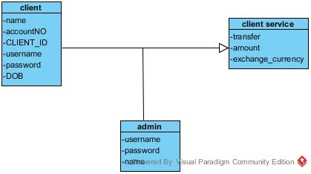

# 3.1.7navigation diagram

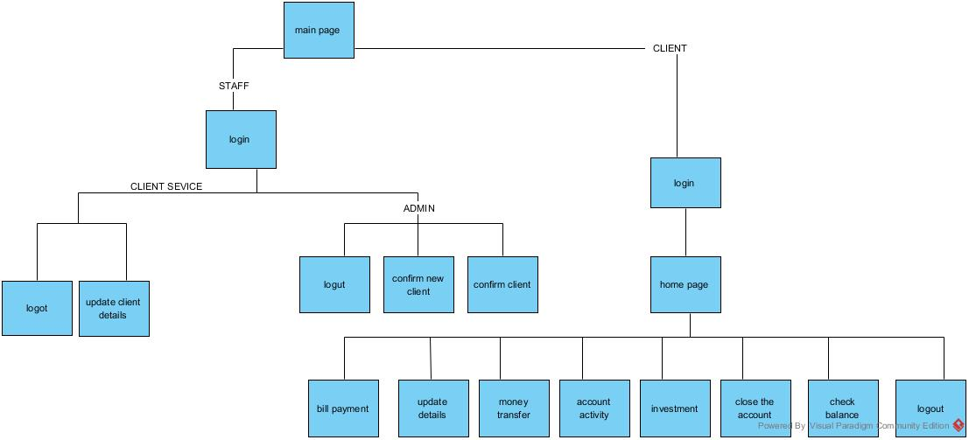

# pHASE 3

**4.1.1Design Class Diagram**

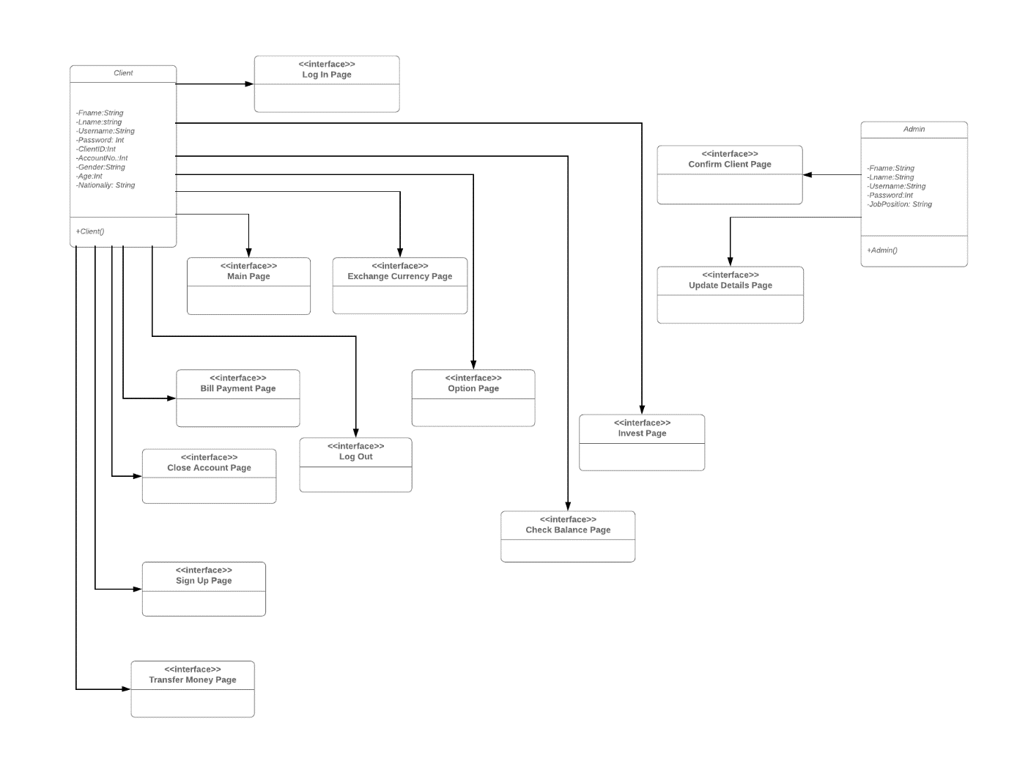

**4.1.2Sequence Diagram**

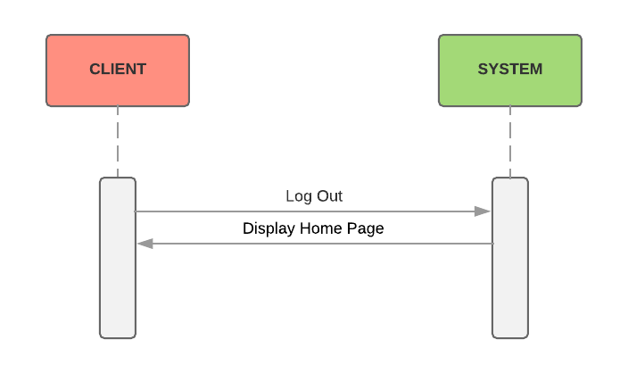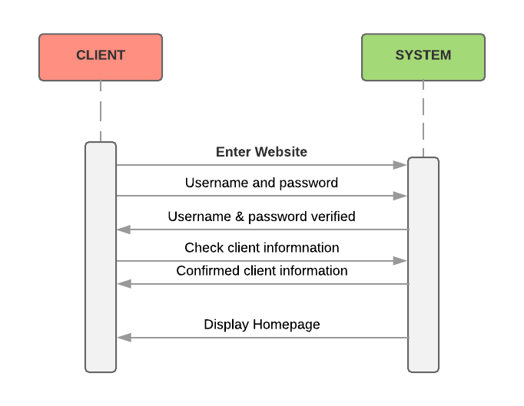

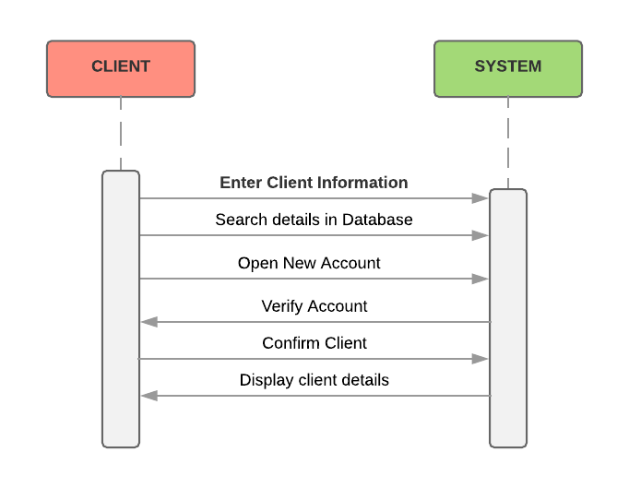

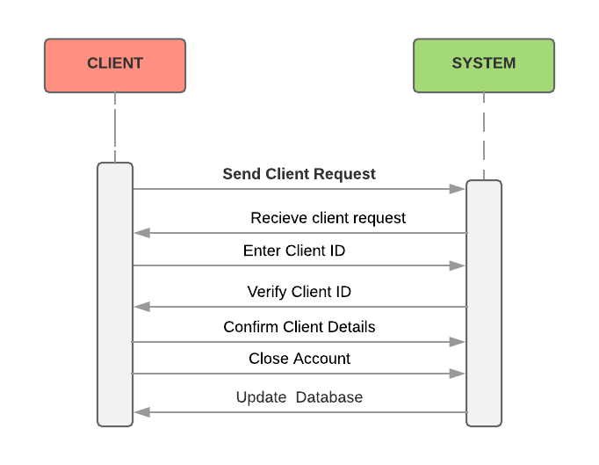

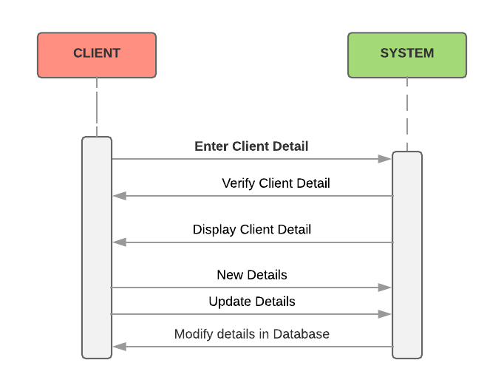

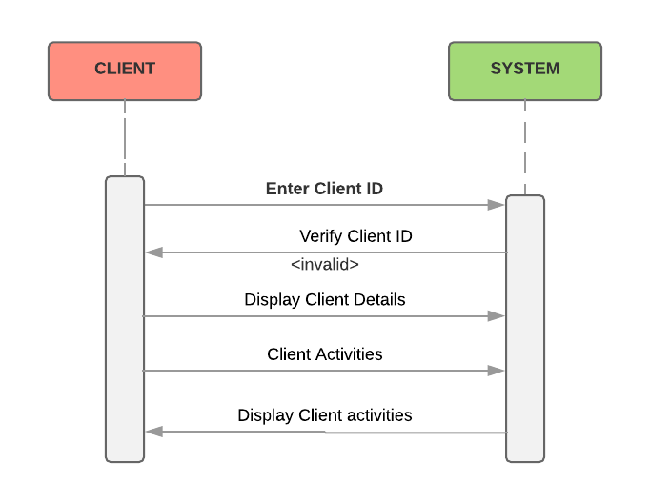

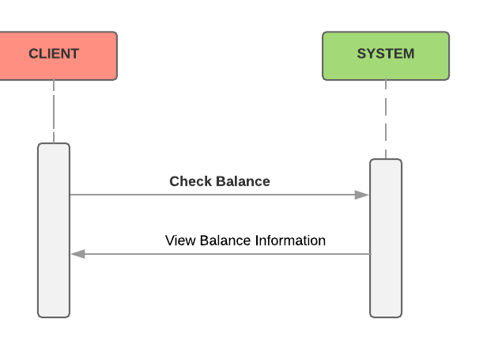

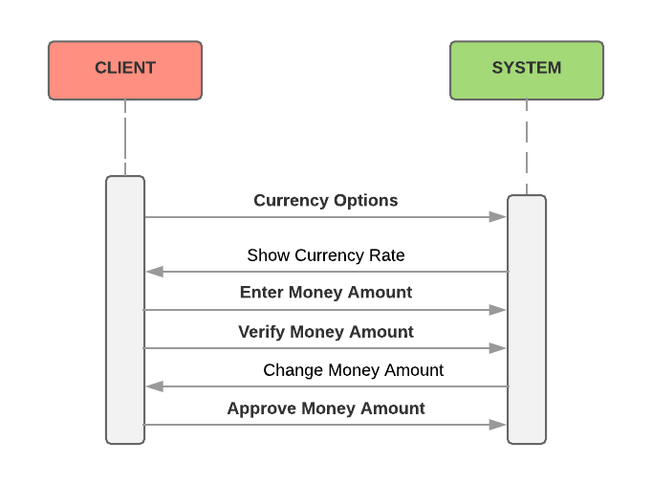

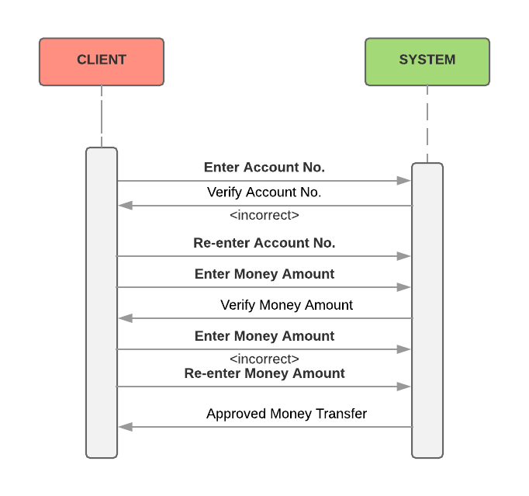

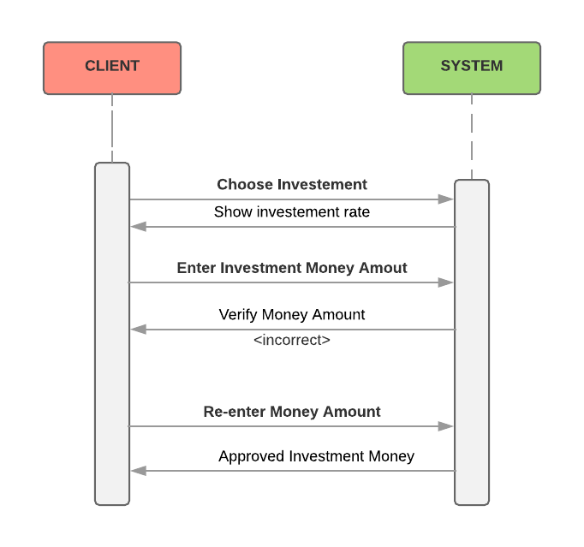

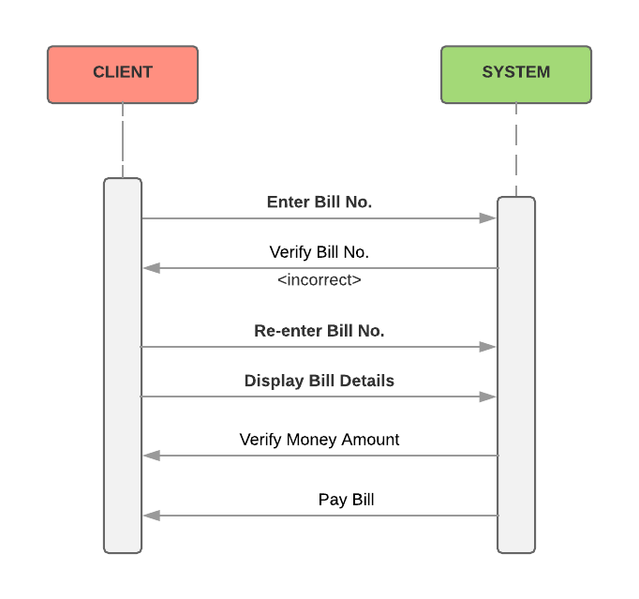

**4.1.4Package Diagram**

